C:\Users\craig.pollard.SLC.000\AppData\Local\Microsoft\Windows\Temporary Internet Files\Content.IE5\D8UVGPH4\MC900295697[1].wmf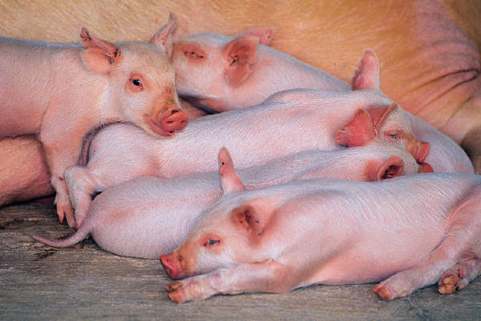

Once upon a time a farmer had fourteen pigs. The pigs didn’t have names, so he thought he should name them. But they all looked the same so he spray painted them different colours, but not fully sprayed that colour. He named them Fred, Bob, Jim, Alfie, Alfred, Ben, Bill, Dobby, Andy, Chris, Sammy, Richard, Smith, Ketchup, and Clarence.