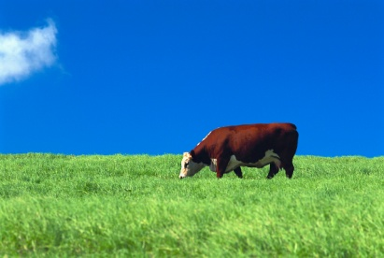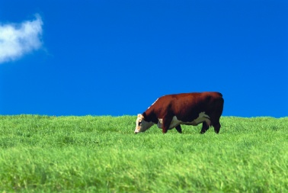C:\Users\hannah.bahrani\AppData\Local\Microsoft\Windows\Temporary Internet Files\Content.IE5\IT9IJ9NN\MC900014771[1].wmf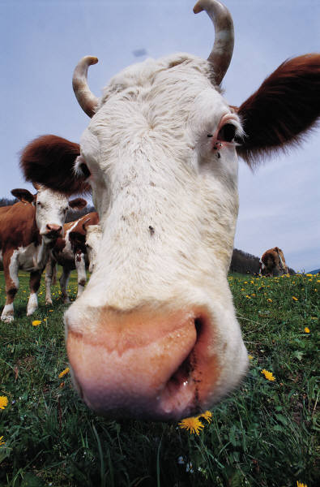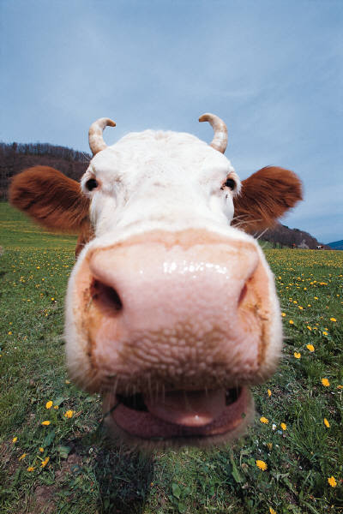

The 3 moos are Hannah [me], Rosie and Mia. We first had the idea of the 3 moos when I went to Mia’s house ... we were walking down the road when I asked Mia if she liked milk and beans she said yes, so we thought we would create a group and we asked Rosie if she wanted to be in and she said yes.

